EV template scrutinization process.

Check Filsets and create ECS file

* Have all .dt4 or .raw files been added?
* Save ECS file to transect specific folder

Check GPS Fixes

* Does track display in proper basin of Lake Erie

Check Platform properties

* Adjust name and notes as needed.

Check transducer properties

* Make sure z – vetical offset (m) is set correctly (1 for Almar, 1.5 for Muskie)
* Adjust orientation as needed (Almar should be good – check for Muskie)

Create new editable lines for SurfaceExclusion_Editable and BottomExculsion_editable

* Right click in data flow window – select New > Editable Line… click ok

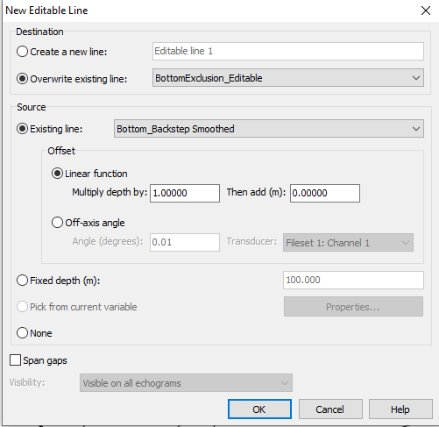 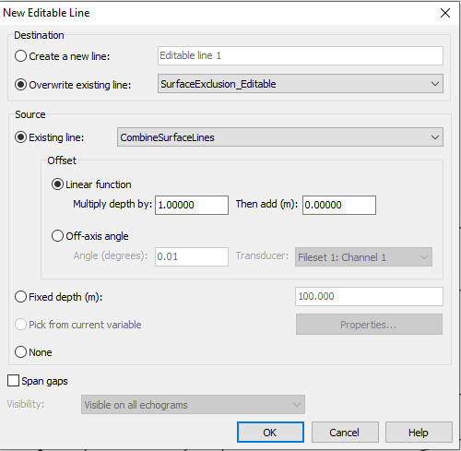

Adjust SurfaceExculsion and BottomExclusion lines and identify bad data regions

1. Expand ‘Sv Noise Removal and Thresholding’ grouping and open ‘Set_Sv_threshold’ variable
2. Right click on echogram and open variable properties – navigate to Lines tab
   1. Remove all lines SurfaceExclusion (Analysis), SurfaceExclusion_Editable, BottomExclusion (Analysis), BottomExclusion_Editable
   2. Save and exit
3. Edit SurfaceExclusion_Editable and BottomExclusion_Editable as needed on echogram
4. Identify and define bad data regions on echogram not captured by noise removal process
   1. Use vertical band tool – right click - define region – Name: Default, Type: Bad data (no data), Class: Bad Data
5. Close ‘Set_Sv_threshold’ variable and collapse ‘Sv Noise Removal and Thresholding’

Identify Epilimnion and Hypolimnion regions

1. Expand ‘Epi Layer Identification’ grouping and open ‘Cell-mean Sv of samples (dB) Epi Layer_Processed’ variable
   1. For West Basin – edit ‘Epi Layer_Editable’ to be below the ‘BottomExclusion’ line
      1. Unless water column YSI profiles indicate stratification
   2. For Central and East Basins – edit ‘Epi Layer_Editable’ to align with the lower edge of the densest layer
   3. Close ‘Cell-mean Sv of samples (dB) Epi Layer_Processed’
2. Create new editable line for ‘Epi Layer Max Smoothed MEAN span gaps_Editable’
   1. Right click in data flow window – select New > Editable Line… click ok

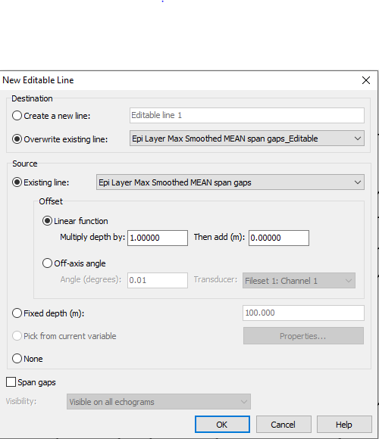

1. Open ‘XxY statistic Epi Layer_Processed’
   1. Edit ‘Epi Layer Max Smoothed MEAN span gaps_Editable’ as needed to match up with fish aggregations and water column profiles
   2. Close ‘XxY statistic Epi Layer_Processed’
2. Collapse ‘Epi Layer Identification’

Double check Line edits, data exclusions, and create line relative regions

* Open ‘ExportSv’
* Make sure four lines are checked SurfaceExclusion, BottomExclusions, Epi Layer Max Smoothed MEAN span gaps_Editable, and EchogramFloor.
* Use horizontal band tool to select data between SurfaceExclusion and Epi Layer Max Smoothed MEAN span gaps_Editable.
  + Right click and choose Define line relative region…

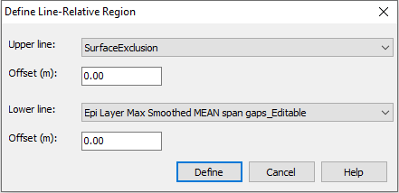

* + Name: G_142_epi, Type: Analysis, Class: Epilimnion
* Use horizontal band tool to select data between Epi Layer Max Smoothed MEAN span gaps_Editable and EchogramFloor.
  + Right click and choose Define line relative region…

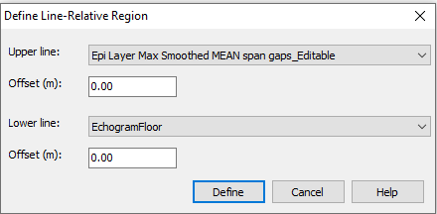

* + Name: G_142_hypo, Type: Analysis, Class: Hypolimnion

Gott to check on the single target thing…